This is a translation of the Swedish original. In case of differences between the English translation and the Swedish original, the Swedish text shall prevail.

Alleima AB’s Remuneration Report 2022

Introduction
This Remuneration Report describes how Alleima AB’s (the “Company”) guidelines for executive remuneration (the “remuneration guidelines”), adopted by an Extraordinary General Meeting, 9 May 2022, have been applied in 2022. The report also provides details on the remuneration of the Company’s President & CEO (the “President”). The report has been prepared in accordance with Chapter 8, Sections 53 a and 53 b of the Swedish Companies Act and the Rules on Remuneration of the Board and Executive Management and on Incentive Programs issued by the Swedish Corporate Governance Board, and now managed by Aktiemarknadens självregleringskommitté (ASK).
Information pursuant to Chapter 5, Sections 40-44 of the Swedish Annual Accounts Act, is available in Note 3 on page 105 in the Company’s Annual Report 2022. Information on the work of the Remuneration Committee in 2022 is set out in the corporate governance report on page 75 of the Annual Report 2022.
Remuneration of the Board of Directors is not covered by this report. Such remuneration is resolved annually by the Annual General Meeting and disclosed in Note 3 on page 105 of the Annual Report 2022.

Overall company performance in 2022
The President summarizes the Company’s overall performance in his statement on pages 10-13 of the Annual Report 2022.

The Company’s remuneration guidelines: scope, purpose and deviations
A prerequisite for the successful implementation of the Company’s business strategy and safeguarding of its long-term interests, including its sustainability, is that the Company is able to recruit and retain qualified personnel. To this end, it is necessary that the Company offers competitive remuneration. The Company’s remuneration guidelines enable the Company to offer the executive management and the President competitive total remuneration.
Under the Company’s remuneration guidelines, remuneration of executive management shall be on market terms, be competitive and reflect the individual’s performance and responsibilities as well as the Group’s earnings trend. The remuneration may consist of the following components: fixed salary, variable remuneration, pension benefits and other benefits.
The remuneration guidelines, adopted by an Extraordinary General Meeting, 9 May 2022, can be found on page 63 of the Annual Report 2022. During 2022, the Company has complied with the applicable remuneration guidelines. No deviations from the guidelines have been decided and no derogations from the procedure for implementation of the guidelines have been made. No remuneration has been reclaimed.
The auditor’s report regarding whether the Company has complied with the remuneration guidelines is available on the Company’s website www.alleima.com.

Remuneration Committee’s evaluation of remuneration
The Remuneration Committee considers that the remuneration guidelines adopted by an Extraordinary General Meeting on 9 May 2022 have worked well and that the purpose of the guidelines has been achieved. Moreover, the Committee considers the Company’s remuneration structures and remuneration levels to be balanced and on market terms.

Total remuneration of the President
The table below sets out total remuneration to the Company’s President relating to 2022. From January to August 2022, the President’s compensation was received from Sandvik for the assignment as President Sandvik Materials Technology (SMT). From September to December 2022, the President received compensation from Alleima as President and CEO of Alleima.
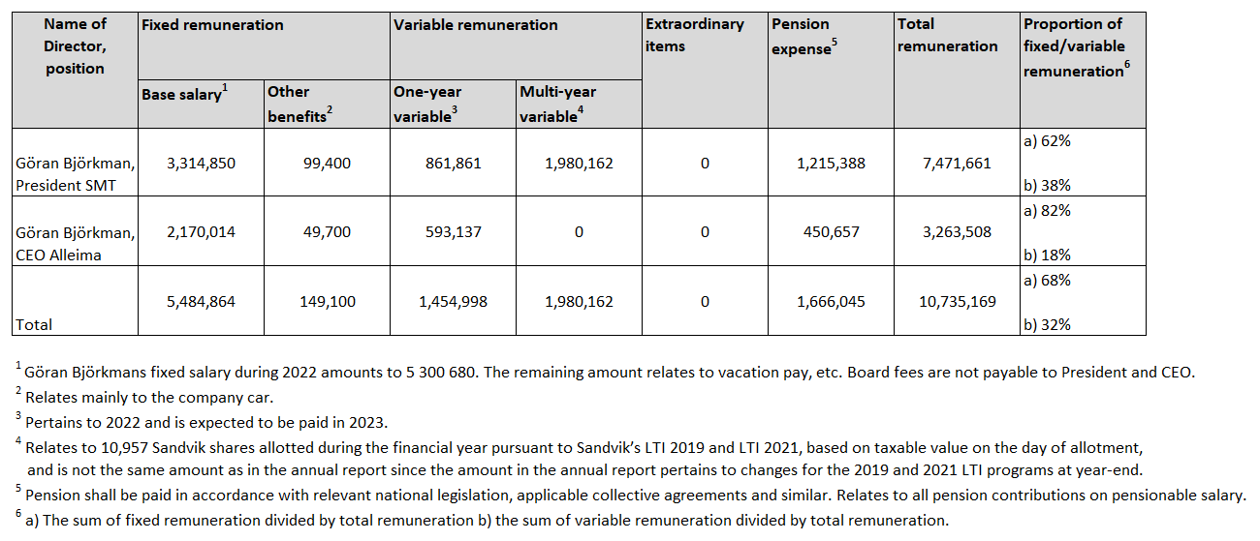
Share and share price related incentive programs to the President
The President and CEO has participated in Sandvik’s long-term share price related incentive program (LTI). Sandvik AB’s Annual General Meetings 2019-2021 resolved, at the suggestion of Sandvik AB’s Board of Directors, to introduce for each year a performance share program for a maximum of 350 senior executives and key employees in the Sandvik group (of which approximately 40 in what is currently Alleima), divided into four categories. For all participants, a personal investment in Sandvik shares is required in each program. Each acquired Sandvik share entitles the participant to be allotted, after a period of three years, a certain number of Sandvik shares free of charge (so-called performance shares), provided that certain performance targets are met and subject to continuous employment and all acquired shares being held during the three-year period. The number of performance shares that will finally be allotted is dependent on the participant category and the adjusted Earnings Per Share (“EPS”) in the program year compared to the previous financial year.
Within the LTI 2019, the President was allotted 4,991 performance shares because the performance targets were to some extent met. Allotment of these performance shares took place in May 2022. Within the LTI 2020, no performance shares were allotted to the President as the performance targets were not met. Performance shares under LTI 2021 would have been allotted to the President as the performance targets were met, but as a result of the separation from the Sandvik group, a reduced number of 5,966 performance shares was allotted to the President in August 2022, based on the number of months from the initial grant in June 2021 until the listing date of Alleima in relation to the program’s total duration (36 months).
As regards the forfeited right to performance shares from the Sandvik LTI 2021, a decision was taken by Alleima’s Board of Directors to implement a program to compensate participants with a cash amount corresponding to the value of the forfeited shares. Payment of the amount will be made in 2024, when the Sandvik program would have ended, provided that the participant is still employed in Alleima.

Variable short-term cash remuneration
Variable short-term cash remuneration is conditional upon the fulfilment of defined and measurable criteria. At the beginning of each year, the Remuneration Committee proposes and the Board of Directors approves the criteria, including key performance indicators (KPIs) and the target ranges, deemed relevant for the upcoming measurement period. At least 80 percent of the variable cash remuneration shall be linked to financial criteria.
The performance criteria for the President and CEO’s short-term variable remuneration aims at promoting the Company’s business strategy and performance as well as its long-term interests, including its sustainability. Set out in the table below is a description of how the criteria for payment of variable short-term remuneration to the President have been applied during the financial year.
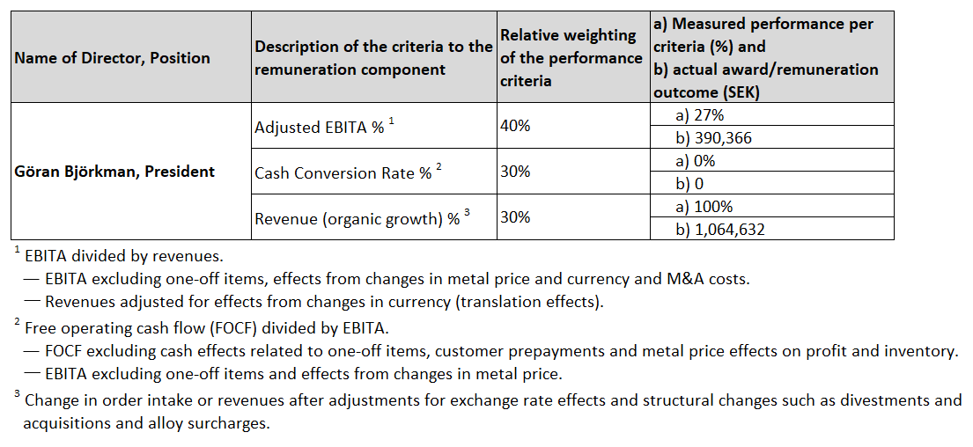

Variable long-term cash remuneration
During 2022, the Board of Directors has resolved on the implementation of a long-term variable cash program (LTI 2022), in which the President and CEO, the other senior executives in the group executive management team and an additional 35 employees within the group participate. As regards to the President and CEO, the value is max 75 percent of the fixed annual cash salary. The program period is three years and payment requires continuous employment in Alleima during a three-year period until the end of 2024, and that the group during 2022 achieves a measurable financial criterion linked to adjusted EBITA.

Remuneration and the Company’s performance for the financial year of 2022 (SEK)
